**Nama : Allan Wydianto**

**Kelas : FWD Batch 4**

**Github : https//github.com/w1shm3luck/mini-project**

Menyelesaikan studi kasus terkait CRUD Query

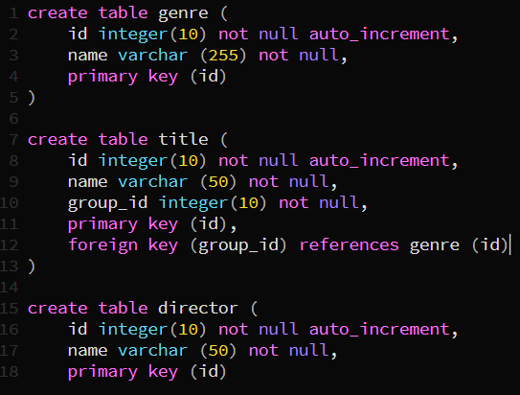Jawaban no.1

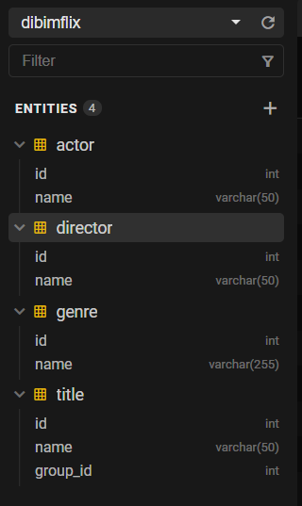

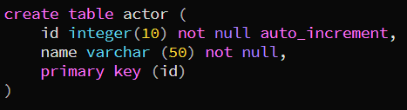

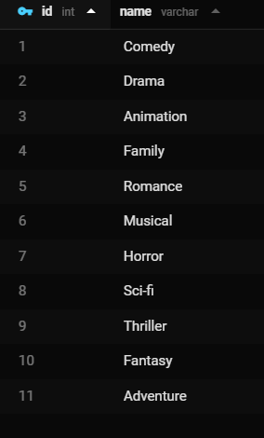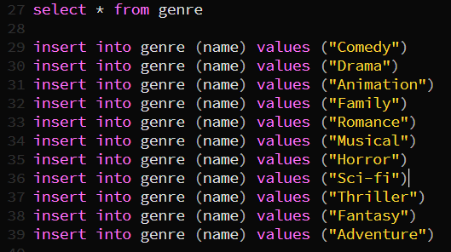2. Jawaban No. 2

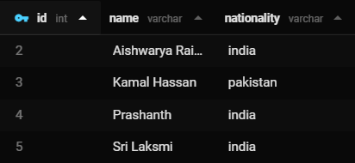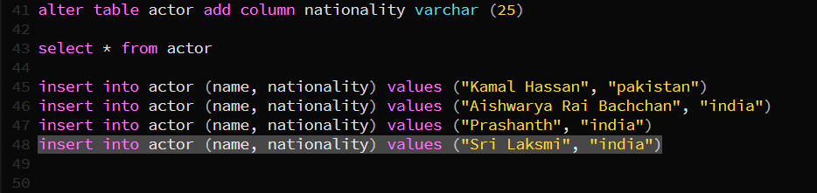3. Jawaban No. 3

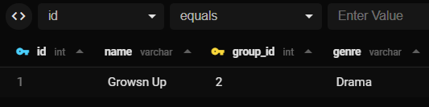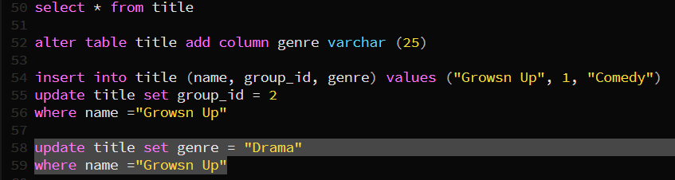4. Jawaban No. 4

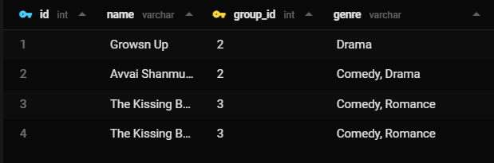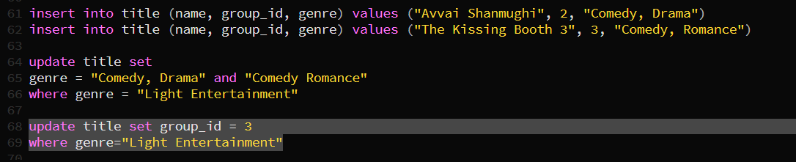5. Jawaban No.5